**Commands to install apache and php in amazonlinux**

sudo yum update -y

sudo yum install httpd -y

sudo systemctl start httpd

sudo systemctl enable httpd

sudo yum clean metadata

sudo yum install php php-cli php-mysqlnd -y

sudo systemctl restart httpd

**Install mysql in amazon linux**

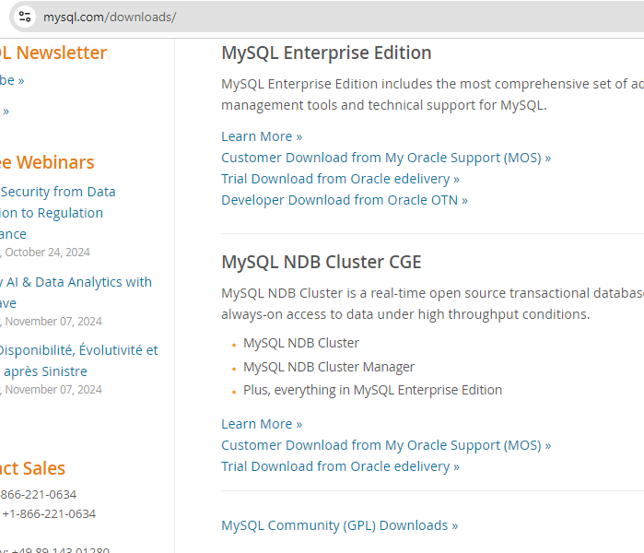

Click mysql community (GPL) downloads

Then choose mysql yum repository

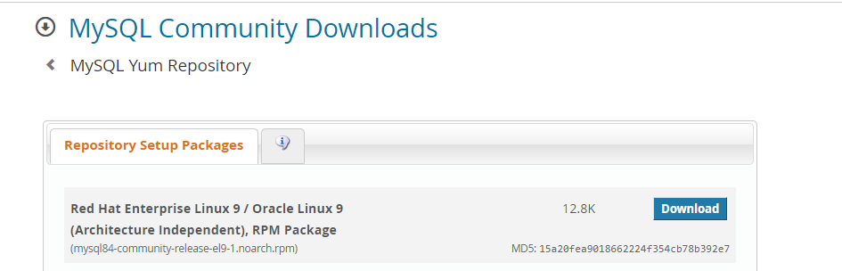

Copy the download link and move to instance and download the rpm file

command : wget [https://dev.mysql.com](https://dev.mysql.com/downloads/file/?id=528548)/get/mysql84-community-release-el9-1.noarch.rpm

After that need to install rpm

Command : ls -ltrh

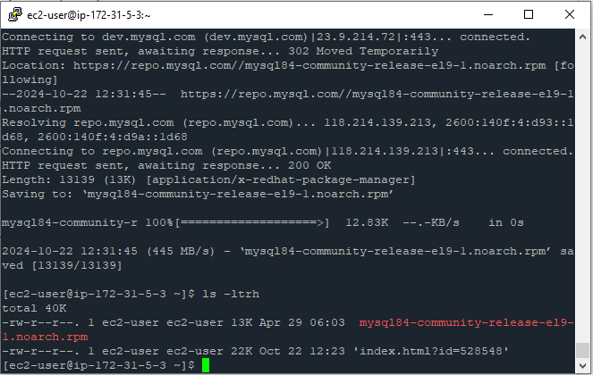

Sudo dnf install mysql84-community-release-el9-1.noarch.rpm

Sudo dnf install mysql-community-server

Sudo systemctl start mysqld

Sudo systemctl status mysqld (to check whether it is in running state)

To get temporary password for root-> sudo cat /var/log/mysqld.log | grep “password”

Sudo mysql -u root -p

Enter the copied password after this command

To change the password-> alter user ‘root’@’localhost’ identified by ‘newpassword’;

